SIMATS ENGINEERING
SAVEETHA INSTITUTE OF MEDICAL AND TECHNICAL SCIENCES
COMPUTER SCIENCE AND ENGINEERING PROGRAMME
CSA1302 - THEORY OF COMPUTATION

LAB EXPERIMENT - 3

Name: J . Anisha Jenifer
Reg No: 192511004

QUESTION
1. Write a C program to find ε -closure for all the states in a Non-Deterministic
Finite Automata (NFA) with ε -moves

AIM
To write and execute a C program to find the ε-closure of all states in a Non-Deterministic Finite Automaton (NFA) containing ε-moves.

ALGORITHM
- Start the program.
- Read the number of states and the number of ε-transitions.
- Initialize the ε-closure of each state to include the state itself.
- Read the ε-transitions as source and destination state pairs.
- Mark each direct ε-transition in the transition matrix.
- Check whether a state can reach another state through one or more ε-transitions.
- Repeat the process until no new reachable states are found.
- Display the ε-closure of every state.
- Stop the program.

3. PROGRAM
#include <stdio.h>
int main() {
int n, e, i, j, k;
int from[100], to[100];
int closure[100][100] = {0};
int changed;
printf("Enter number of states: ");
scanf("%d", &n);
if (n < 1 || n > 100) {
printf("Invalid number of states\n");
return 0;
}
printf("Enter number of epsilon transitions: ");
scanf("%d", &e);
if (e < 0 || e > 100) {
printf("Invalid number of transitions\n");
return 0;
}
for (i = 0; i < n; i++) {
closure[i][i] = 1;
}
printf("Enter epsilon transitions (from to):\n");
for (i = 0; i < e; i++) {
scanf("%d %d", &from[i], &to[i]);

if (from[i] < 0 || from[i] >= n ||
to[i] < 0 || to[i] >= n) {
printf("Invalid state number\n");
return 0;
}
closure[from[i]][to[i]] = 1;
}
do {
changed = 0;
for (i = 0; i < n; i++) {
for (j = 0; j < n; j++) {
if (closure[i][j]) {
for (k = 0; k < n; k++) {
if (closure[j][k] &&
!closure[i][k]) {
closure[i][k] = 1;
changed = 1;
}
}
}
}
}
} while (changed);
printf("\nEpsilon-closure of each state:\n");
for (i = 0; i < n; i++) {
printf("E-closure(q%d) = { ", i);
for (j = 0; j < n; j++) {
if (closure[i][j]) {
printf("q%d ", j);
}
}
printf("}\n");
}
return 0;

4. OUTPUT
The program was executed with the input string "abba".
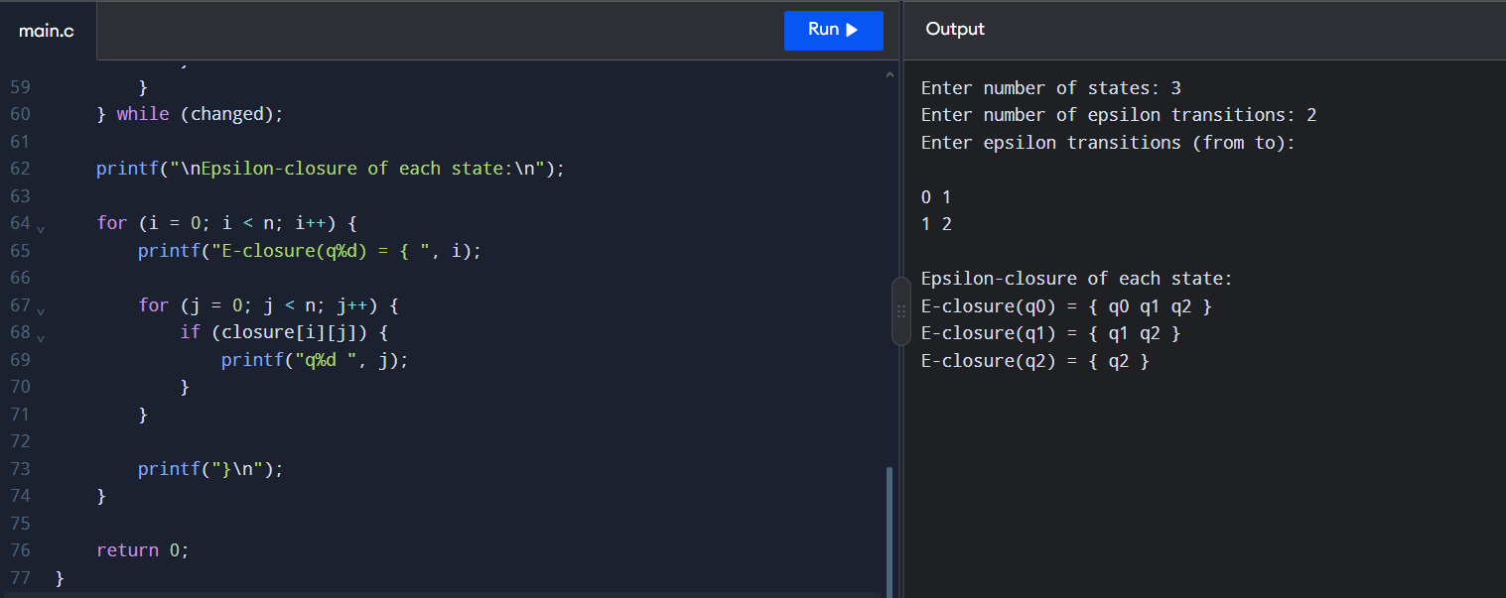

5. RESULT
Thus, the C program to find the ε-closure of all states in an NFA with ε-moves was written and executed successfully.
Remember: The ε-closure of a state always contains the state itself, along with every state reachable through zero or more ε-transitions.

